Project Development Phase
Performance Test
Date | 10 February 2025
Team ID | SWTID-2026-7644
Project Name | Script-Controlled ACL – Restrict Record Access Based on Field Value
Maximum Marks | 10 Marks
Model Performance Testing:
Project team shall fill the following information in model performance testing template.
S.No | Parameter | Screenshot / Values
1. | ACL Configuration | Record-level ACL configured for read access on the Institution Details table.  Type: record  Operation: read  Decision: Allow if  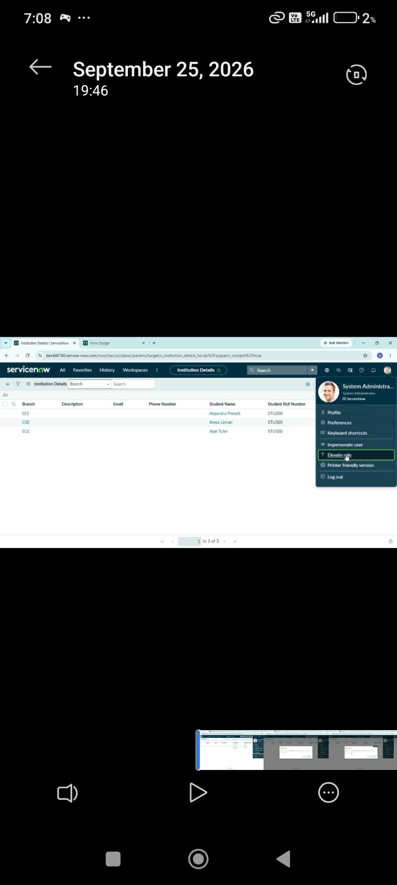
2. | Data / Record Validation | Institution Details records are available with Branch, Student Name and Student Roll Number fields.  The ACL checks the selected field value before allowing access.  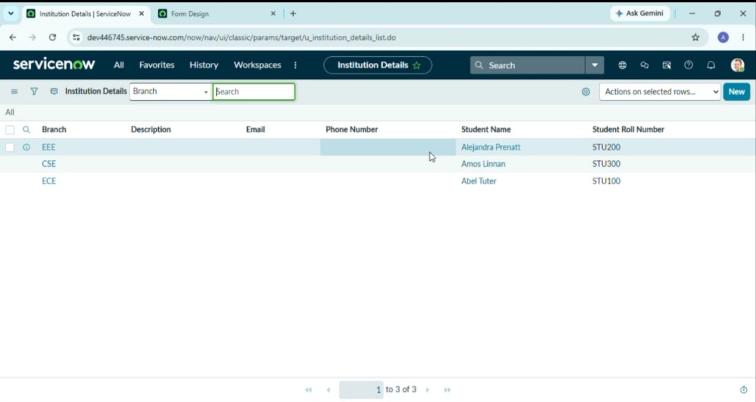
3. | Utilization of Field Value | Branch field is used as the access-control condition.  Example: EEE records are allowed when the configured condition is satisfied; other field values are restricted.  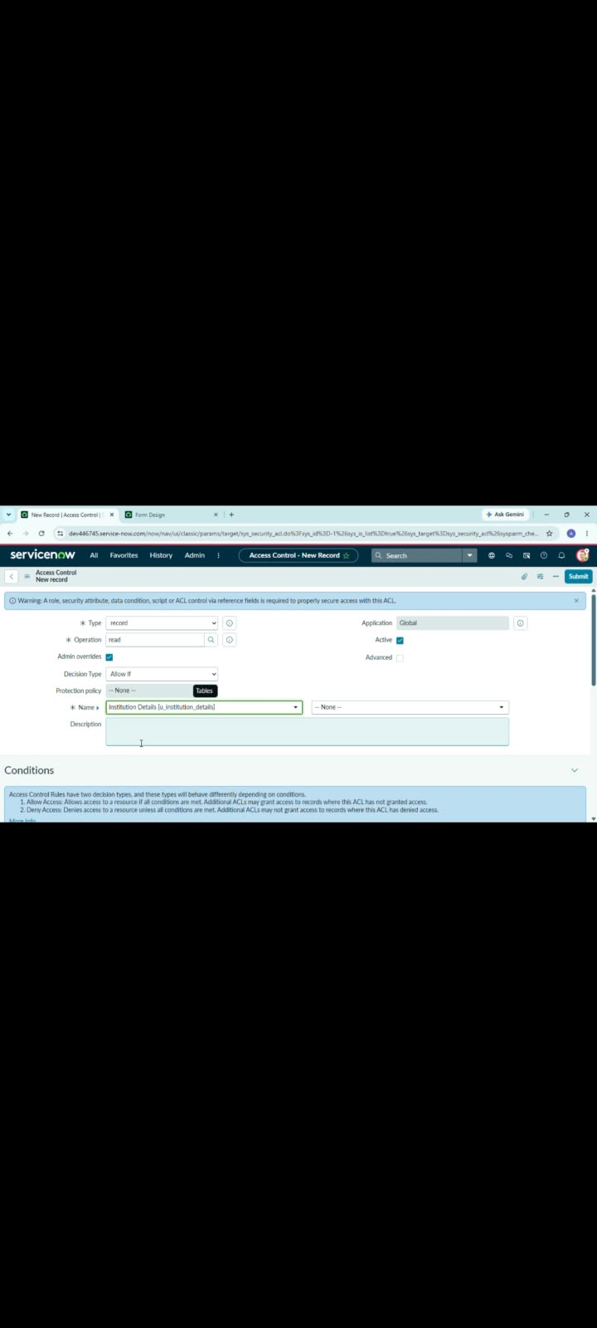
4. | Script Evaluation | The ACL script evaluates the field value at request time and returns the access decision.  Result: condition satisfied → Allow; condition not satisfied → Deny.
5. | Authorized Access | Authorized user can view the permitted record after the ACL condition is satisfied.  Expected Result: requested record is displayed without exposing restricted records.
6. | Unauthorized Access | When the field value does not satisfy the configured rule, access to the protected record is blocked.  Expected Result: restricted record information is not exposed.  